FSMA Cyber Compliance for Log360

**Tagline** – Achieve FSMA Cyber compliance with continuous monitoring and advanced threat detection using Log360.

**Overview**
The FSMA Cyber Compliance extension for Log360 helps Belgian financial services organizations align with the Financial Services and Markets Authority's cybersecurity requirements. By integrating this extension, IT and security teams gain comprehensive visibility into their cyber security posture.
Log360 continuously collects and correlates log data from Active Directory, Windows, Unix/Linux, Microsoft 365, cloud platforms, and network devices, mapping events directly to FSMA Cyber standards. Security teams can track compliance status in real time, investigate incidents quickly, and generate audit-ready reports with a single click.

**Key Features:**
- Generate comprehensive audit-reports mapped to all FSMA Cyber security requirements and controls.
- Aggregates logs from various sources including servers, workstations, network devices, cloud platforms, and applications in real-time.
- Correlates logs from different sources to detect threats, anomalies, and suspicious activities with advanced rules.
- Export reports in PDF and CSV format for auditors, management, or regulatory submissions.

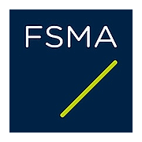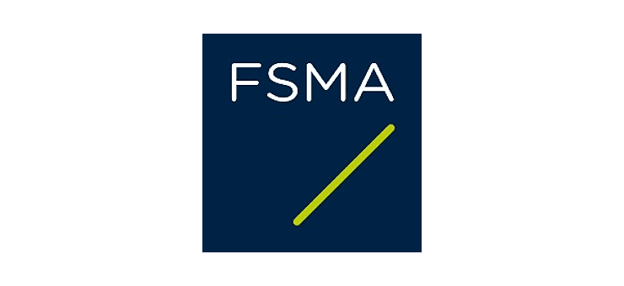
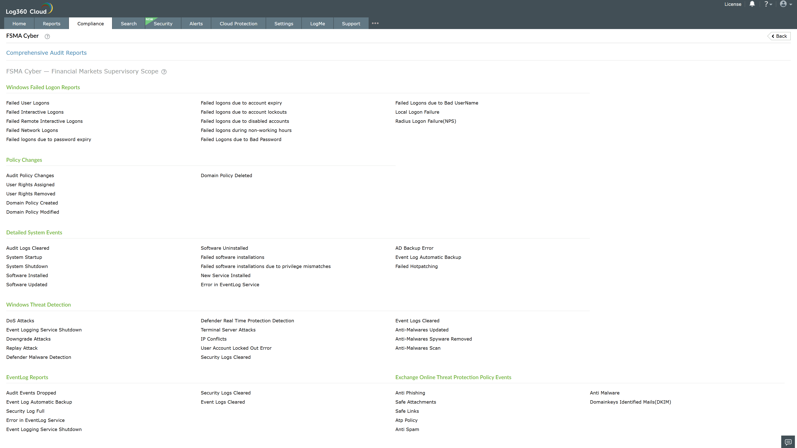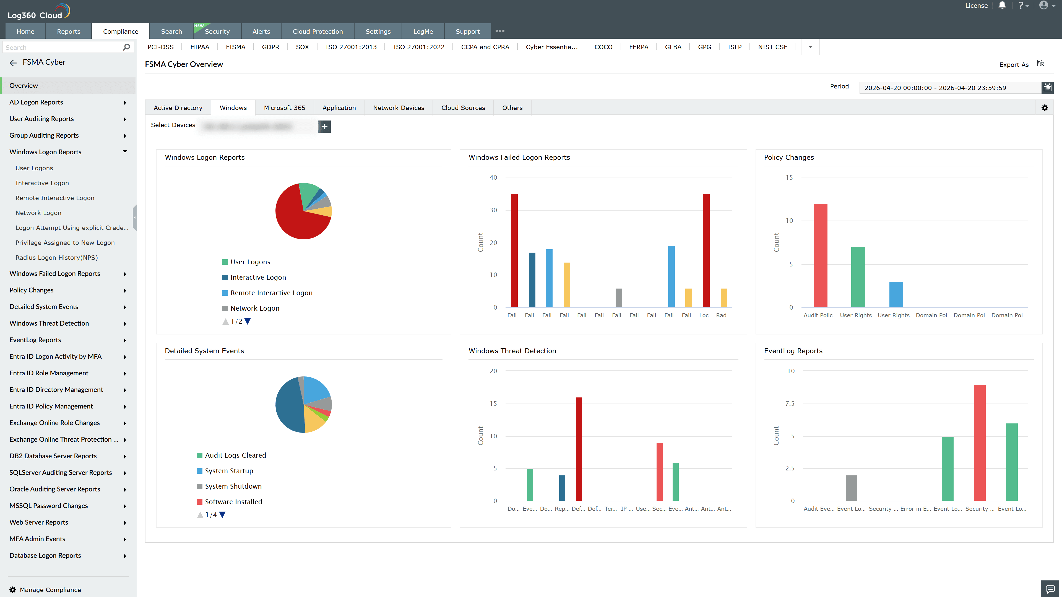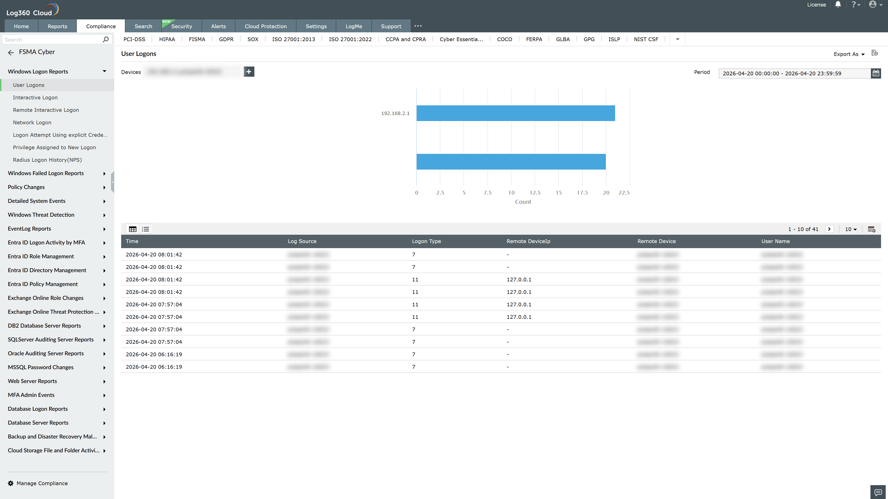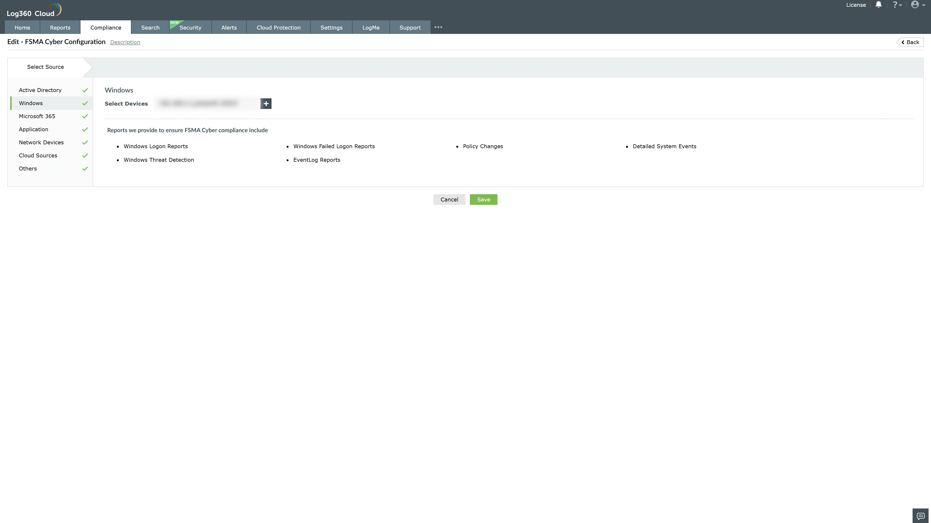
Valid Submission : Yes
Supported Editions : Free, Basic, Standard, Professional, MSSP
Help Document : https://www.manageengine.com/log-management/help/integrations/compliance-extensions.html
Help Video : Not provided
Tags : Log360, Compliance, Privacy monitoring, Data privacy, Regulatory compliance
Supported DCs : US, IN, JP, CA, AU, UK and EU
Privacy Policy:
Terms of Service:
Release Notes:
Predefined reports for the FSMA Compliance.

